**Semester 1 (Unit 3) Examination, 2017**

**Question/Answer Booklet**

**MATHEMATICS APPLICATIONS**

**Section One: Calculator-assumed**

Student Name/Number: ______________________________________________

Teacher Name: ______________________________________________

**Time allowed for this section**

Reading time before commencing work: ten minutes

Working time for this section: one hundred minutes

**Materials required/recommended for this section**

**To be provided by the supervisor:** This Question/Answer Booklet

Formula Sheet (retained from Section One)

**To be provided by the candidate:**

Standard items: pens (blue/black preferred), pencils (including coloured), sharpener,

correction fluid/tape, eraser, ruler, highlighters

Special items: drawing instruments, templates, notes on 2 unfolded sheets of A4 paper, and up to three calculators approved for use in the WACE examinations

**Important note to candidates**

No other items may be taken into the examination room. It is **your** responsibility to ensure that you do not have any unauthorised notes or other items of a non-personal nature in the examination room. If you have any unauthorised material with you, hand it to the supervisor **before** reading any further.

**Structure of this paper**

|  |  |  |  |  |  |
| --- | --- | --- | --- | --- | --- |
| Section | Number of questions available | Number of questions to be answered | Working time (minutes) | Marks available | Percentage of exam |
| Section One: Calculator-free | 6 | 6 | 50 | 50 | 35 |
| Section Two: Calculator-assumed | 10 | 10 | 100 | 100 | 65 |
|  | | | | | 100 |

**Instructions to candidates**

1. The rules for the conduct of School exams are detailed in the *College assessment policy*. Sitting this examination implies that you agree to abide by these rules.
2. Write your answers in this Question/Answer Booklet.

3. You must be careful to confine your responses to the specific questions asked and to follow any instructions that are specific to a particular question.

1. Spare pages are included at the end of this booklet. They can be used for planning your responses and/or as additional space if required to continue an answer.
   * Planning: If you use the spare pages for planning, indicate this clearly at the top of the page.
   * Continuing an answer: If you need to use the space to continue an answer, indicate in the original answer space where the answer is continued, i.e. give the page number. Fill in the number of the question that you are continuing to answer at the top of the page.
2. **Show all working clearly.** Your working should be in sufficient detail to allow your answers to be checked readily and for marks to be awarded for reasoning. Incorrect answers given without supporting reasoning cannot be allocated any marks. For any question or part question worth more than two marks, valid working or justification is required to receive full marks. If you repeat any question, ensure that you cancel the answer you do not wish to have marked.
3. It is recommended that you **do not use pencil**, except in diagrams.
4. The Formula Sheet is **not** to be handed in with your Question/Answer Booklet.

**Section Two: Calculator-assumed 65% (100 Marks)**

This section has **10** questions. Answer **all** questions. Write your answers in the spaces provided. Spare pages are included at the end of this booklet. They can be used for planning your responses and/or as additional space if required to continue an answer.

* + Planning: If you use the spare pages for planning, indicate this clearly at the top of the page.
  + Continuing an answer: If you need to use the space to continue an answer, indicate in the original answer space where the answer is continued, i.e. give the page number. Fill in the number of the question that you are continuing to answer at the top of the page.

Suggested working time: **100 minutes**.

**Question 7 (7 marks)**

Jan is planning a fitness program. The distance she will run each day starts with 75 m on the first day and increases by 50 m each day.

(a) Enter the data for the sequence into the table below. (2 marks)

|  |  |  |  |  |  |
| --- | --- | --- | --- | --- | --- |
| **Day** | 1 | 2 | 3 | 4 | 5 |
| **Number of metres** |  |  |  |  |  |

(b) Represent the data on the grid provided. (3 marks)

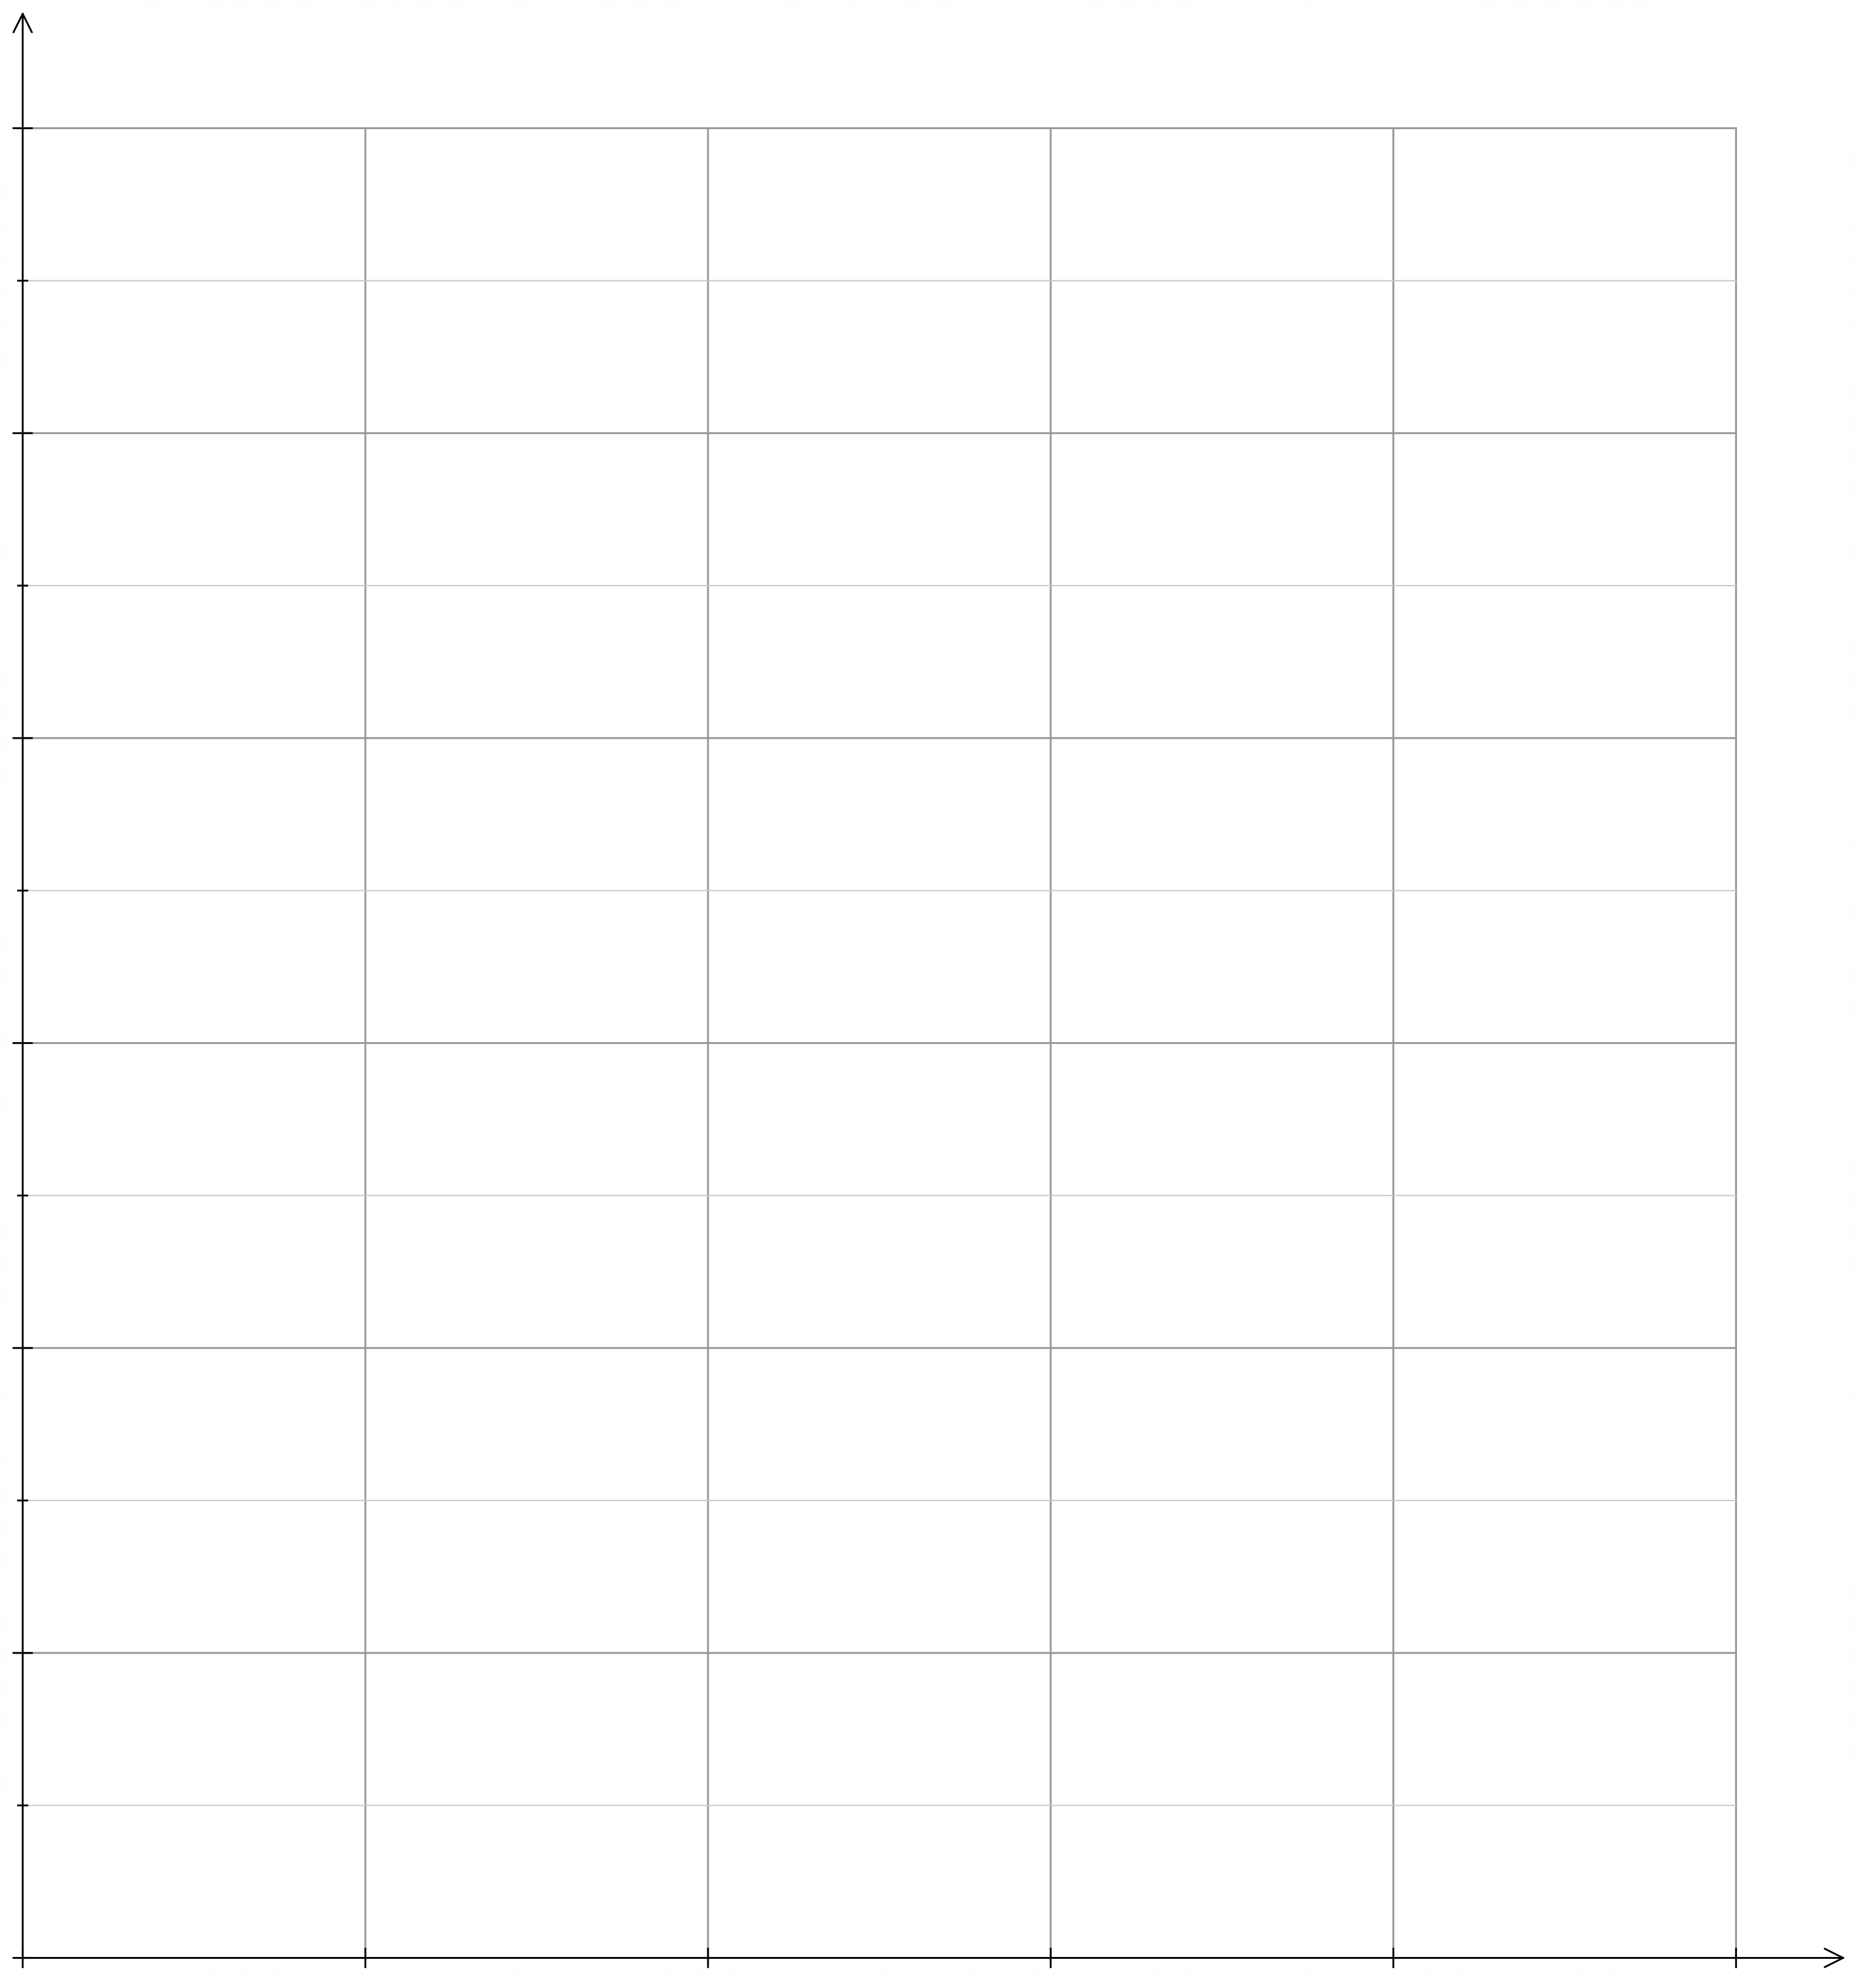

(c) Deduce the rule for the nth term of the sequence. (2 marks)

**Question 8 (10 marks)**

Students conducting a survey about preferred lesson time at the local pool wanted data to support their theory that preferred lesson time was affected by the age of the swimmers.

To collect data, 25 people were chosen at random from four different age groups and asked to indicate their preferred lesson time.

The results of the survey are shown in the table below.

|  |  |  |  |  |  |  |
| --- | --- | --- | --- | --- | --- | --- |
|  |  | Lesson times | | | |  |
| Age group | Age range | 4 pm | 5 pm | 7 pm | 8 pm | Total |
| Primary | 5 to 12 | 10 | 7 | 6 |  | 25 |
| Secondary | 12-18 | 5 | 7 | 10 | 3 | 25 |
| Tertiary | 19-25 | 4 | 5 | 7 | 9 | 25 |
| Older adult | Over 25 | 2 |  | 4 | 16 |  |
|  | Total |  | 23 | 27 | 30 | 100 |

(a) Enter the missing data into the table above. (2 marks)

(b) Determine the percentage of survey respondents who preferred the 7 pm lesson time. (1 mark)

(c) Determine the percentage of Tertiary students who preferred the 4 pm lesson time.

(1 mark)

(d) For the people who prefer the 8 pm lesson time, compare the percentage who are in Secondary with those who are in Tertiary. (2 marks)

(e) Describe the association between age group and preferred lesson time in general and for particular age groups. (4 marks)

**Question 9 (10 marks)**

Gary needs to drive from Bibe (B) to Gato (G) as quickly as possible. A network showing the towns, the possible routes and the distances (km) between towns is provided.

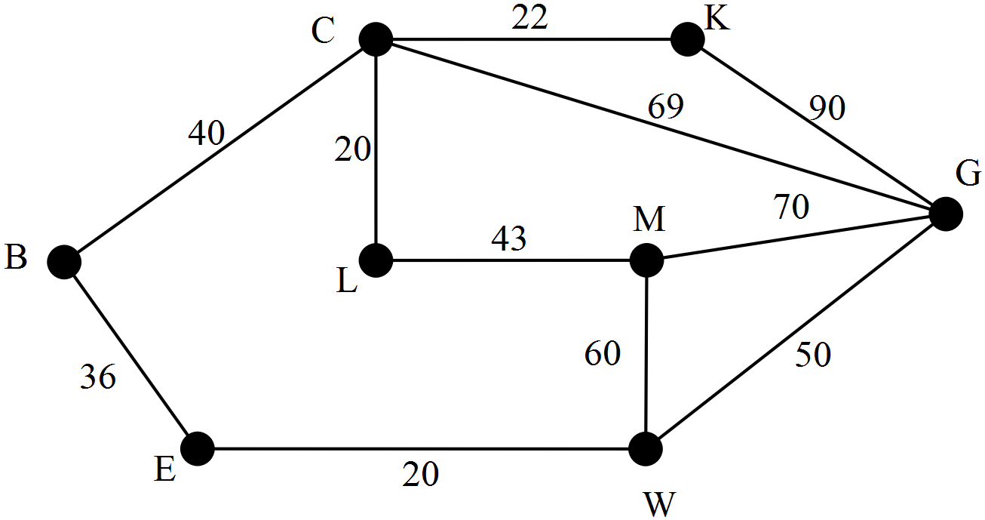

(a) Name the shortest distance from Bibe to Gato and state the distance.

Provide evidence of the processes used to determine this route. (5 marks)

(b) Why can this shortest route also be described as a path? (2 marks)

(c) If Gary needs to return to Bibe via Lome (L), will this affect the route he should take?

Justify your conclusion with reference to the shortest route through Lome.

(2 marks)

(d) Is this graph an example of a weighted graph? Explain. (1 mark)

**Question 10 (17 marks)**

The heights of 7 lighthouses in Western Australia are recorded in the table below. The ranges, the distance that the lights can be seen from, are recorded for each lighthouse.

|  |  |  |
| --- | --- | --- |
| **Lighthouse** | **Height**  **(metres)** | **Range**  **(nautical miles)** |
| A | 19 | 14 |
| B | 39 | 25 |
| C | 30 | 22 |
| D | 39 | 26 |
| E | 14 | 15 |
| F | 20 | 25 |
| G | 15 | 11 |

(a) Create a labelled scatter plot to show the relationship between the two variables, height and range, using range as the response variable. (6 marks)

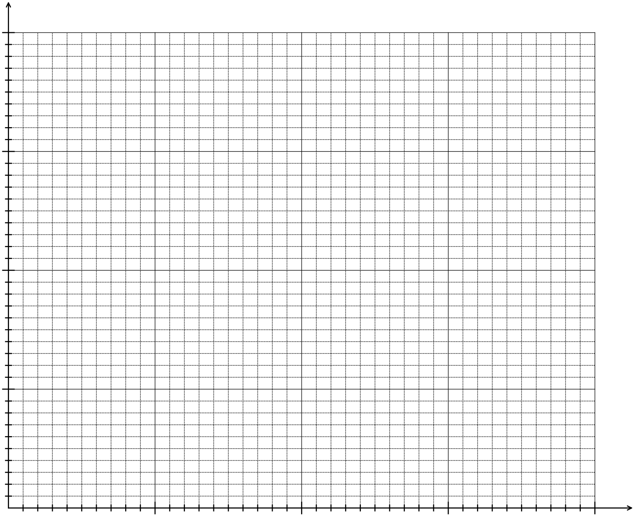

(b) Determine the equation of the least squares line that models the linear relationship between the two variables.

(2 marks)

(c) Draw the least squares line on the grid containing the scatter plot. (2 marks)

(d) Use your graph to determine which lighthouse has the range most different in value from the predicted trend. Explain your choice of lighthouse. (2 marks)

(e) Calculate coefficient of determination. (1 mark)

(f) Use your equation from part (b) to predict the range for a lighthouse with a height of 25 metres. (2 marks)

(g) In terms of the reliability of your prediction;

(i) suggest one reason to support the suggestion that this prediction is reliable.

(ii) suggest one reason to support the suggestion that this prediction is unreliable.

(2 marks)

**Question 11 (12 marks)**

The level of water in a tank is recorded twice each day, at 6 pm and at 6 am.

At 6 pm on the first day the level is 2000 L and at 6 am the following morning, the level has dropped 7.5%. Before 6 pm that day 150 L are added to the tank.

(a) Record in the table the levels of water in the tank every 12 hours starting from 6 pm on the first day. (2 marks)

|  |  |  |  |  |  |  |  |
| --- | --- | --- | --- | --- | --- | --- | --- |
| Recording | 1 | 2 | 3 | 4 | 5 | 6 | 7 |
| Water level (L) |  |  |  |  |  |  |  |

(b) Complete the graph showing the water levels at the times of the recordings.

(3 marks)

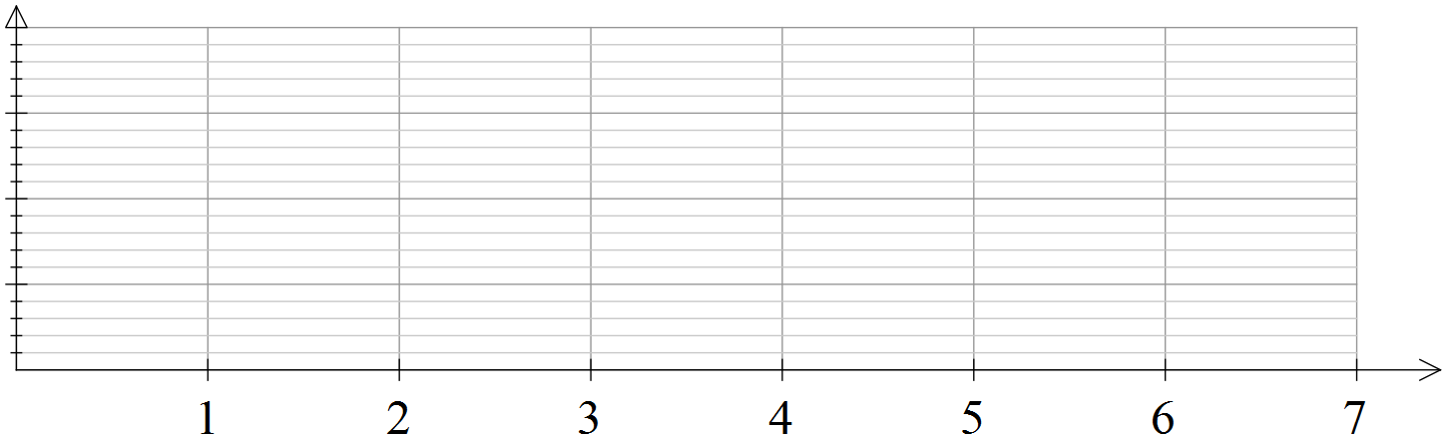

(c) What is the long-term trend for the water level if this pattern continues?

(1 mark)

(d) Explain why the trend from part (c) continues.

(1 mark)

(e) Determine the equation for this first order linear recurrence relation.

(3 marks)

(f) The water in the tank on an adjacent property can also be formulated as a first order linear recurrence relation.

W1 = 1700, Wn + 1 = 1.1Wn – 200

Write down the second and third terms for this sequence. (2 marks)

**Question 12 (10 marks)**

Leah is driving along suburban streets checking that dogs are on their leads.

She needs to travel along every street and can finish at a different place to her starting point. Leah has been told to work out a route to avoid going down any street more than once.

A diagram in which the edges represent the streets which Leah needs to check is provided.

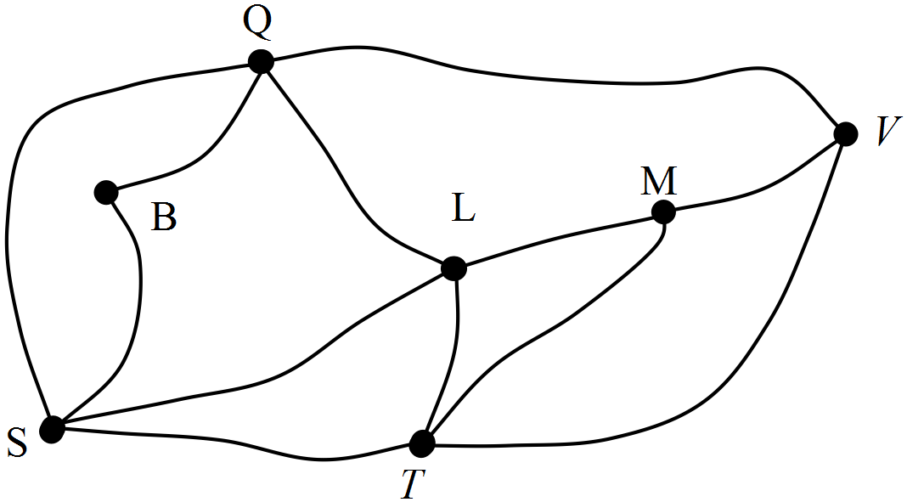

(a) If each edge of the graph represents a street, what do the vertices represent?

(1 mark)

(b) Leah is shown the streets on the map and told that she needs to start her check from an **odd vertex**? From which vertex(vertices) could she start? (1 mark)

(c) Determine a route that Leah could select which allows her to travel down every street without repeating any streets. (3 marks)

(d) Why is a network a suitable way to represent the suburban streets that Leah needs to check? (1 mark)

(e) Show that Euler’s rule applies to this network. (2 marks)

(f) Explain why this network can be called an Eulerian graph?

(2 marks)

**Question 13 (12 marks)**

The populations of two weeds are recorded each week for seven weeks.

The numbers for each population form a sequence. The sequences for each weed are plotted on the axes below.

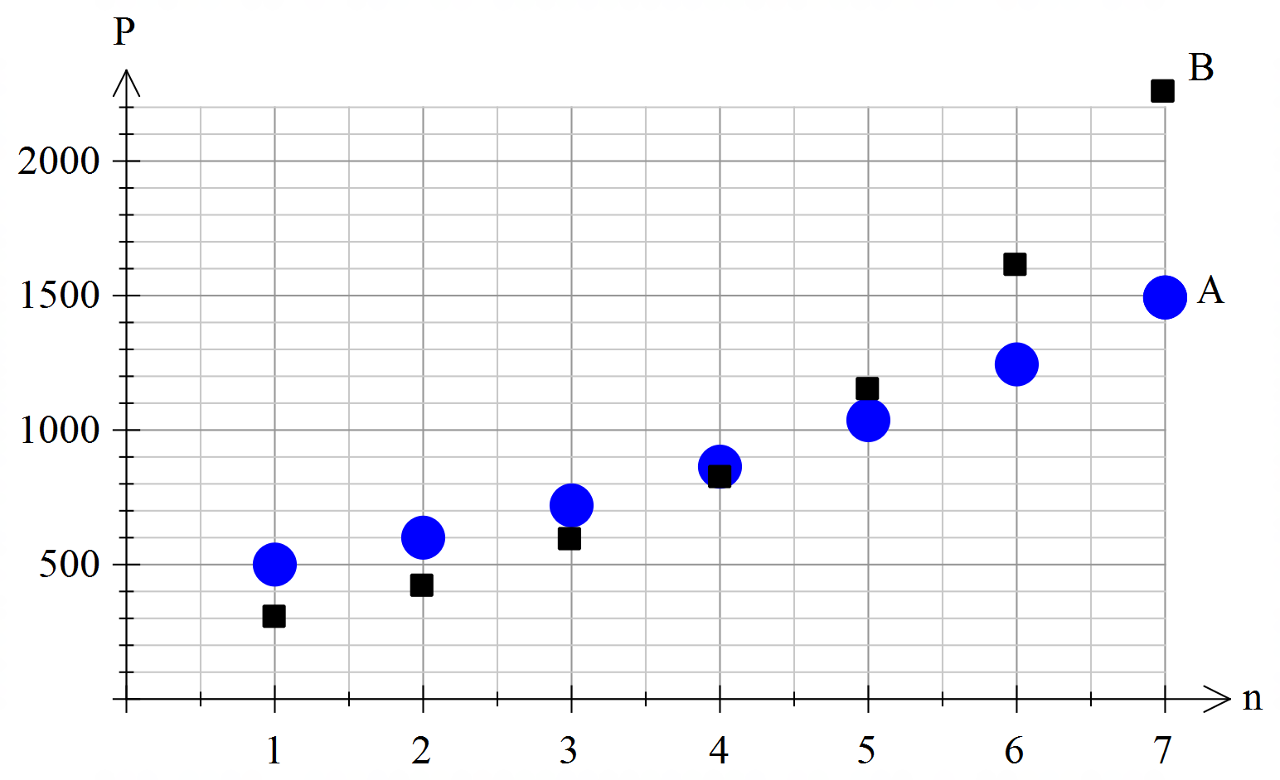

The equation to determine the weed population for A is P = 500 (1.2) n - 1

P: number in the population

n: week on which the population was recorded

(a) What was the population of A weeds at the first recording?

Justify your answer. (2 marks)

(b) Use the equation for population A to determine the number of A weeds at Week 10.

(1 mark)

(c) State the rate at which the A weeds were growing over these seven weeks. (1 mark)

(d) Which of the two populations was growing at the faster rate?

Justify your choice of answer. (2 marks)

(e) Is the sequence for population B arithmetic or geometric? Explain your decision.

(2 marks)

(f) For which week of both sequences were the populations closest in size? (1 mark)

(g) Identify the equation to determine the population of B weeds. (3 marks)

**Question 14 (12 marks)**

The following graph shows the flight paths between cities and these cities are represented by capital letters. Kath wants to visit each city once only, starting and ending at city A.

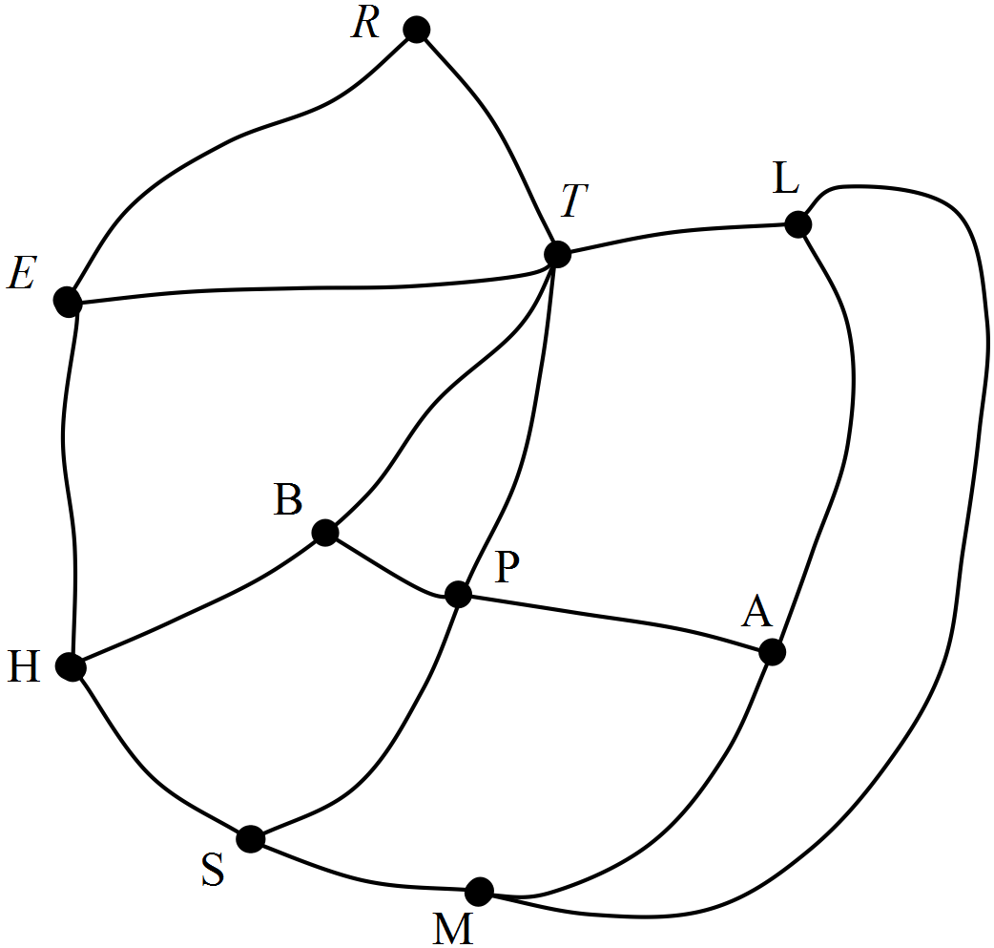

(a) Name one route she could take. (3 marks)

(b) How many edges of this network graph are not needed to show Kath’s route?

Name them. (2 marks)

(c) Does the route described in (a) form a Hamiltonian cycle?

Justify your decision. (2 marks)

(d) Does the route described in (a) form a semi-Eulerian graph?

Justify your decision. (2 marks)

(e) For each of the following statements, write TRUE or FALSE according to the accuracy of the statement. For each statement write a short explanation for your choice of TRUE or FALSE. (3 marks)

(i) The network forms a connected graph.

(ii) The network graph is a simple graph.

(iii) BPHS can also be called a “walk”,

**Question 15 (5 marks)**

The adjacency matrix for the roads connecting towns A, B, C, D, E and F is provided.

The towns are represented within the rows and columns in that same order.

Draw the graph represented by this adjacency matrix.



**Question 16 (5 marks)**

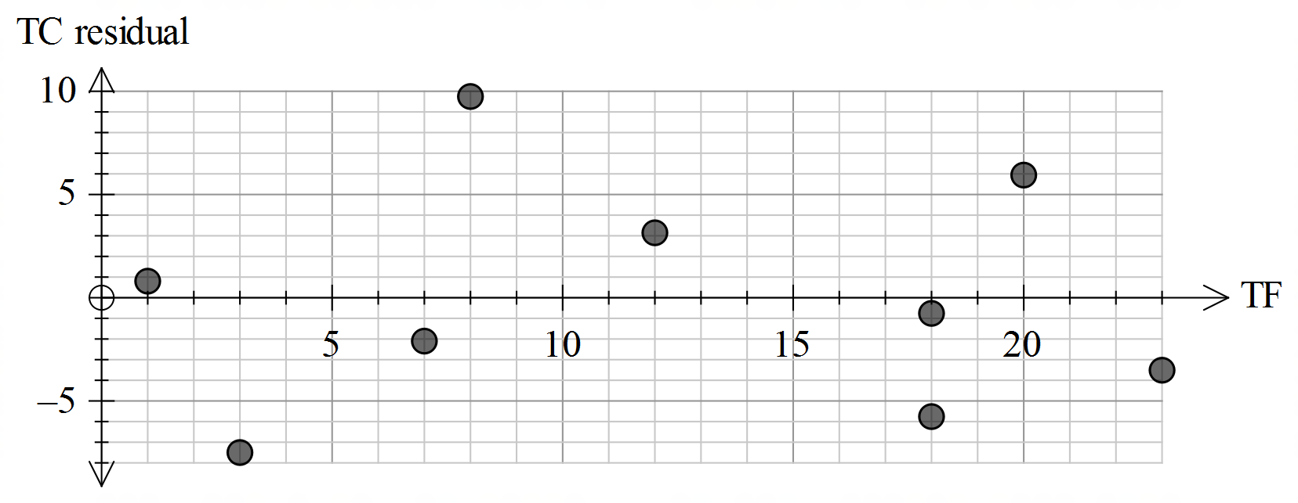

The graph shows the residual plot made after a least squares line was determined between Total fat (TF) and Total carbohydrate (TC) in different biscuits.

(a) Explain, using an example from the plot, what is meant by a “residual”.

(2 marks)

(b) Why are some residuals negative? (1 mark)

(c) Explain the purpose of creating a residual plot, describing how the plot is used.

(2 marks)

**End of Questions**

Additional working space

Question number: __________________

Additional working space

Question number: __________________

**Acknowledgements**

Data for Question 10 was sourced from the website for “Lighthouses of Australia Inc.”

<http://www.lighthouses.org.au/lights/index.asp>

© MAWA, 2017

This examination is Copyright but may be freely used within the school that purchases this licence.

* The items that are contained in this examination are to be used solely in the school for which they are purchased.
* They are not to be shared in any manner with a school which has not purchased their own licence.
* The items and the solutions/marking keys are to be kept confidentially and not copied or made available to anyone who is not a teacher at the school. Teachers may give feedback to students in the form of showing them how the work is marked but students are not to retain a copy of the paper or marking guide until the agreed release date stipulated in the purchasing agreement/licence.

*Published by The Mathematical Association of WA*

*12 Cobbler Place, MIRRABOOKA 6…*